***MUNCH ON PETALS***

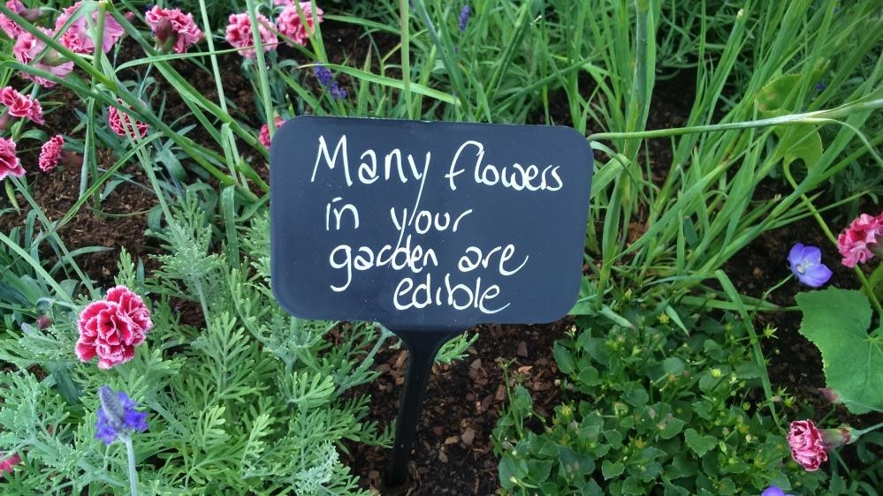

If you’re going to interplant flowers and vegetables/fruit in a kitchen garden bed, why not use edible flowers to extend the range of crops? Alternatively, your existing garden flowers can provide decorations and salad ingredients throughout the year. In the RHS Kitchen Garden, Juliet has included a colourful flowerbed to attractive pollinators, with the added advantage of using edible flowers. Dianthus, agastache, lavender, calendula, hollyhocks, and campanula are amongst the edible flowers in the garden. We also grow borage and nasturtiums in the vegetable beds to bring in the insects and provide edible flowers for the kitchen.